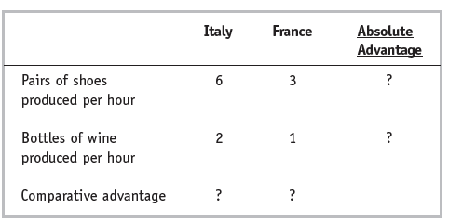

1. Which country has absolute advantage in the production of shoes? Wine?
2. Which country has a comparative advantage in the production of shoes? Wine?
3. Does Italy gain from trading with France?
4. Would your answers to the problem be different if a worker in Italy becomes more productive and produces 9 pair of shoes and 3 bottles of wine per hour?
5. Would your answers to the problem be different if a worker in Italy becomes more productive and produces 8 pair of shoes and 3 bottles of wine per hour?